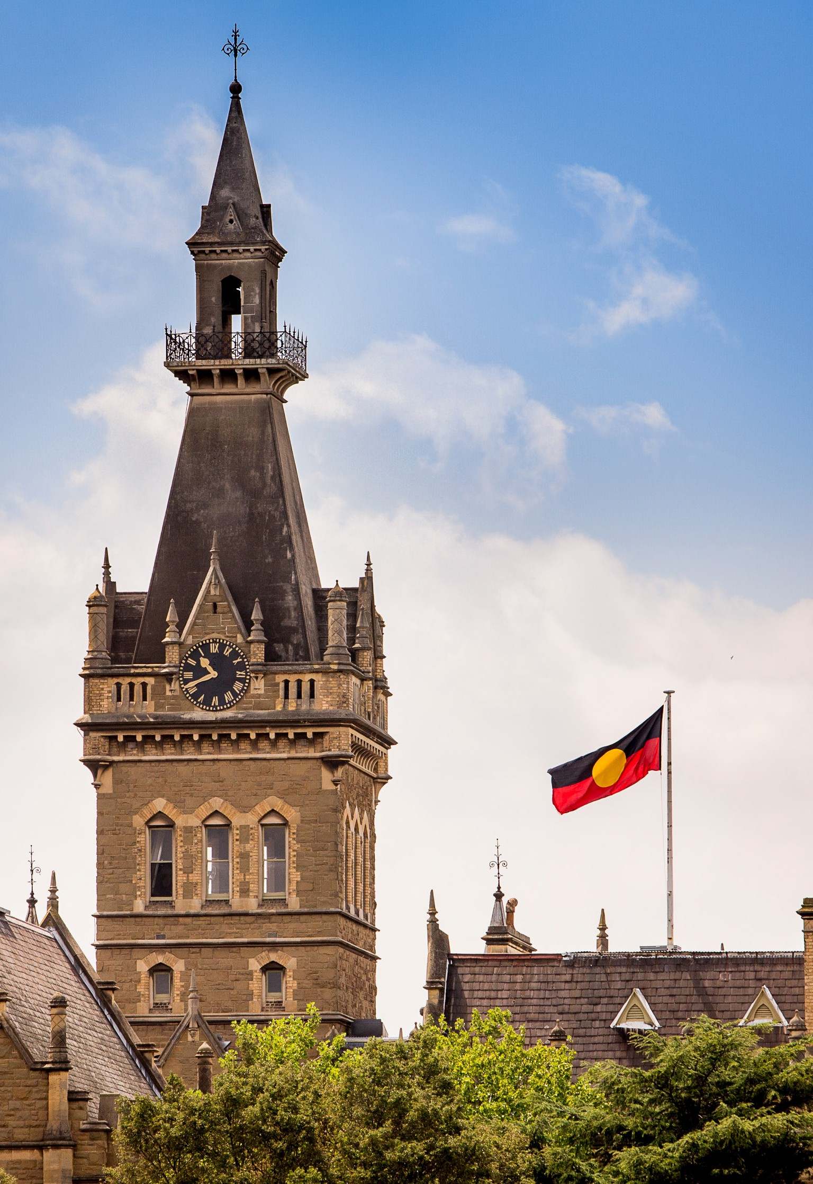
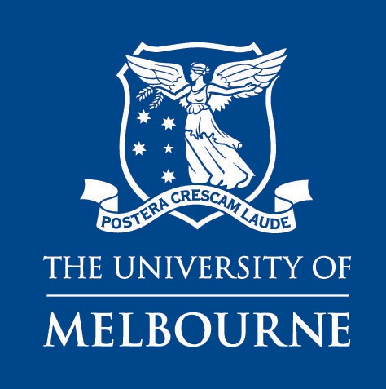

Position Description
Melbourne Indigenous Professional Employment Program 2021

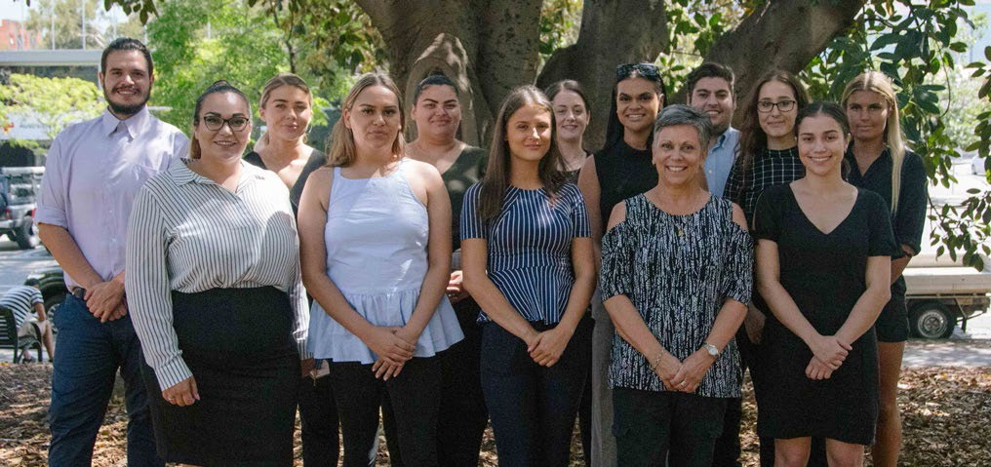
Image:2019 MIPEP Cohort

Melbourne Indigenous Professional Employment Program 2021
–

The University of Melbourne offers Indigenous Australians a two-year development opportunity through the provision of direct work activities and a rotation between two business areas. There are multiple positions available across various teams.

Hiring areas will provide MIPEP participants training in systems and processes relevant to their position and the roles on offer are administration and business support duties.
Within the first 12 months, participants are required to complete a nationally recognised qualification at the diploma level which will be delivered by AFL SportsReady on campus.

In addition, participants are required to attend professional development and enrichment activities and supported to create and drive their career development through a dedicated mentor.

Vacant positions under MIPEP will be based in various locations across Parkville campus.

Page 2 | The University of Melbourne

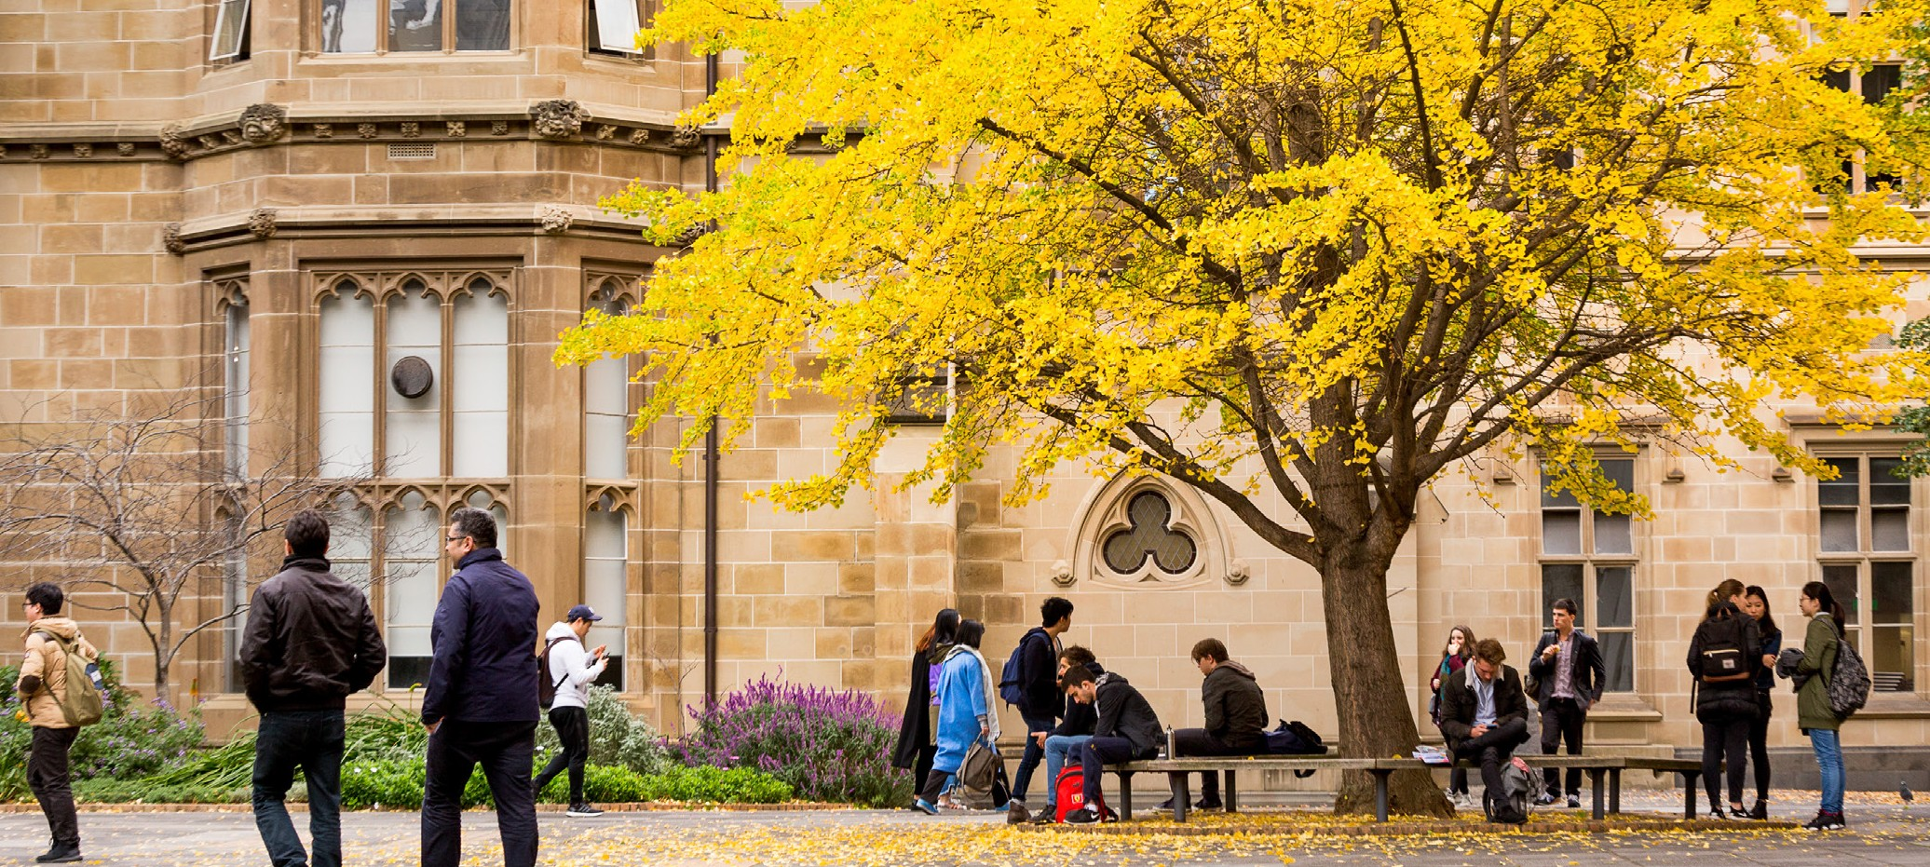

About the University of Melbourne

–
We invest in our people and celebrate one another’s differences that enrich and diversify our community.

We’re tightly connected with our communities, at home and around the globe – a connection that enriches our learning, teaching and research.

We employ people of outstanding caliber and offer a unique environment where staff are valued and rewarded. Our professional, administrative and support staff create a world-class working environment and enable academics to continue achieving internationally renowned excellence in research and teaching.

The University of Melbourne is an equal opportunity employer and our recruitment process focuses on essential skills and abilities. We are committed to fostering an inclusive environment where diversity is celebrated. We encourage and welcome applicants from a diverse range of backgrounds.

The Indigenous Employment Framework (IEF) 2018 - 2021 is the University’s action plan to build on the success of the previous frameworks and continues to grow and retain the Indigenous staff workforce since 2010. It is now in its third iteration and will continue to address the overall target set out in 2013 which is to achieve population parity by December 2025. For more information see murrupbarak.unimelb.edu.au

The University of Melbourne | Page 3

Job related information
–

Position Title
UOM Level and Salary: Basis of Employment: Superannuation: Working Hours:

Contact for Enquiries only:
MIPEP 2021
UOM 4 - $67,872 per annum (pro rata for part-time) Fixed term available for two years
Employer contribution 9.5% Full Time (1 FTE)

Leanora Stuart| leanora.stuart@unimelb.edu.au
| +61 3 8344 6840 | 0466 943 710
Please do not send your application to this contact

- Occasional work out of ordinary hours and travel is required for some positions on offer
- Occasional travel and overnight stay are a part of the professional development and enrichment activities for all positions on offer
- Allocated study time during and outside of working hours is expected for the diploma
- This position may be required to travel to and work across campuses
How to apply: AFL SportsReady is managing all incoming applications. All applications must be sent to applications@aflsportsready.com.au with the email subject line stating, 'Application for Melbourne Indigenous Professional Employment Program 2021'.
Applicants are require to provide a Confirmation of Aboriginality and/or a Statutory Deceleration form to be eligible for the Melbourne Indigenous Employment Program.

For more information about working at the University, visit: unimelb.edu.au/careers

Page 4 | The University of Melbourne

About the roles
–
To be successful in our roles, you will be a team player, who thrives at providing
excellent service and is committed to development.

Core accountabilities
  - Standard use of a range of computer-based programs, e.g. word processing, established spreadsheet or database applications, and management of information systems (e.g. financial, student or human resource systems). This may include storing and retrieving documents, lay out of correspondence and reports, merge, move and copy, use of columns, tables and basic graphics and data entry
  - Provide general administrative and business support to other staff including setting up meetings, answering queries and directing others to appropriate personnel
  - Arrange catering or liaising with service providers for various needs
  - Provide client focused services and continually maintain and develop positive relationships with employees, students and colleagues
  - Occupational Health and Safety (OH&S) and Environmental Health and Safety (EH&S) responsibilities as required

Key selection criteria
  - High attention to detail with the ability to prioritise task, identify issues, problem solve and improve processes
For example: What tasks are you currently responsible for, what issues have risen, how did you solve the issues and what was put in place to rectify the issues arising again.
  - Demonstrated effective written and verbal communication skills to adapt to a wide range of stakeholders
For example: Provide an explanation of a time you have had to communicate with a manager, client and/or customer.
  - Committed team player with the capability to collaborate to achieve team goals. Strong interpersonal skills with the ability to build rapport
For example: In the past how have you adapted your communication style to suite a specific situation or people.

The University of Melbourne | Page 5

Next steps

Online Applications
Submit your application online to AFL SportsReady | applications@aflsportsready.com.au
Subject line: ‘Application for Melbourne Indigenous Professional Employment Program 2021’
Applications close on Sunday 18 July 2021.

Outcomes
All candidates will be notified of the outcome of their application by: Friday 30 July 2021

MIPEP Information Day
Monday 9 August 2021.
The Information Day will give shortlisted applicants in-depth detail on the Melbourne Indigenous Professional Employment Program.

MIPEP Assessment and Panel Interviews
Tuesday 10 August 2021.
Shortlisted applicants are required to undertake a literacy and numeracy assessment to better inform position placements and level of assistance required to complete the diploma. Interviews will also be conducted on this day.

Please Note
AFL SportsReady will be in contact with successful applicants as soon as possible if any required changes to the Information Day or Assessment and Interviews are necessary in response to COVID-19.

Page 6 | The University of Melbourne

